Restoring From AWS Glacier with CommVault (Replacing Tape)

To restore data from AWS Glacier

1. Navigate to the client and job you want to restore

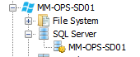

1. Locate where the media is stored. ***View Media***for the job. If the data has aged off disk then you will need to retrieve it from AWS.

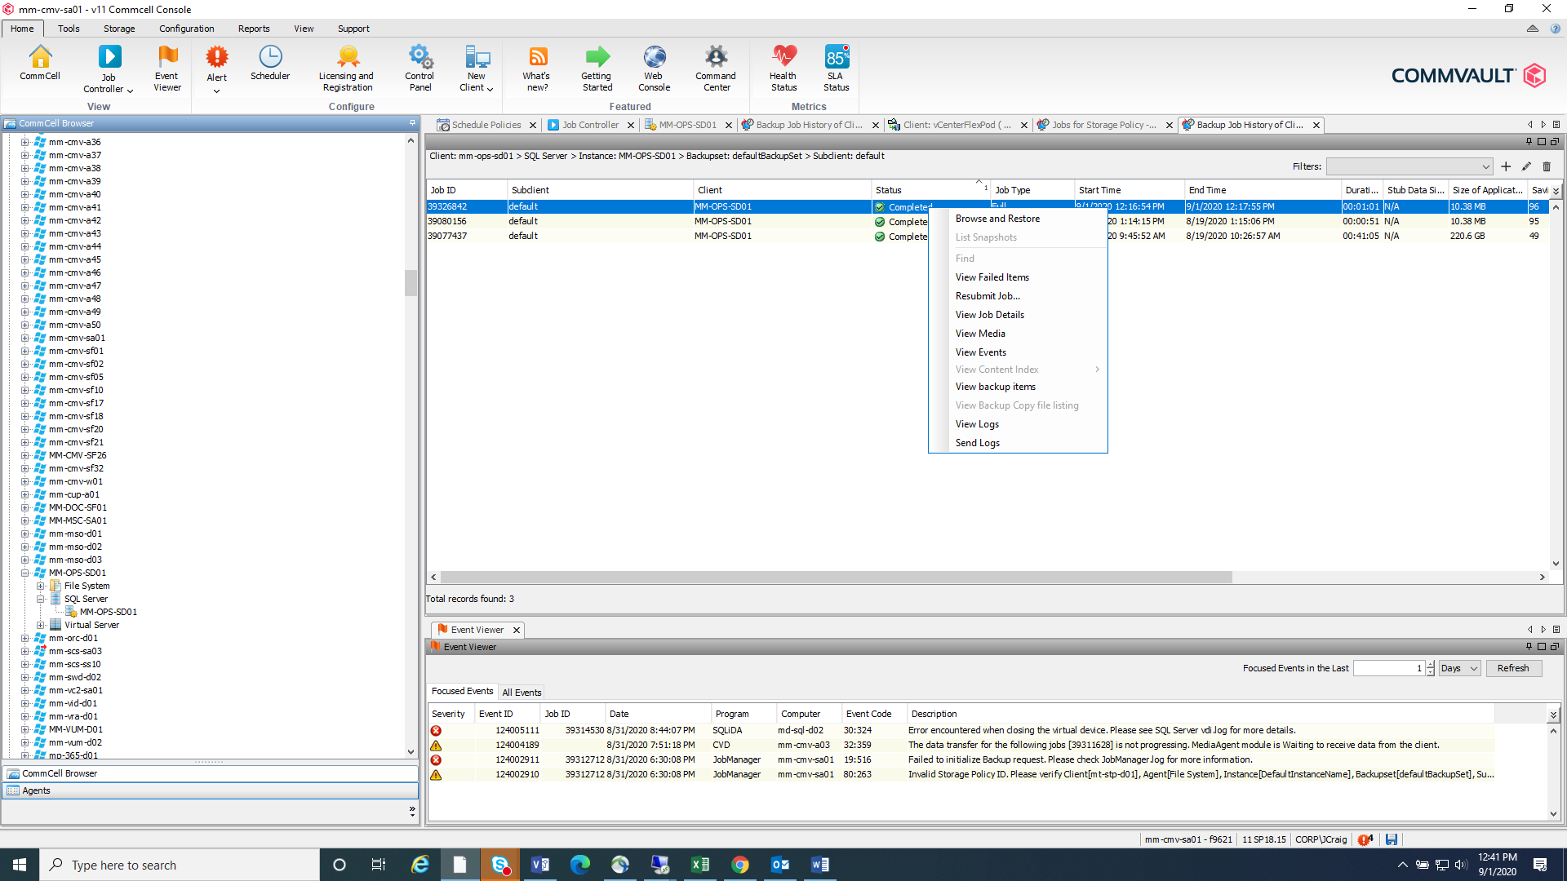

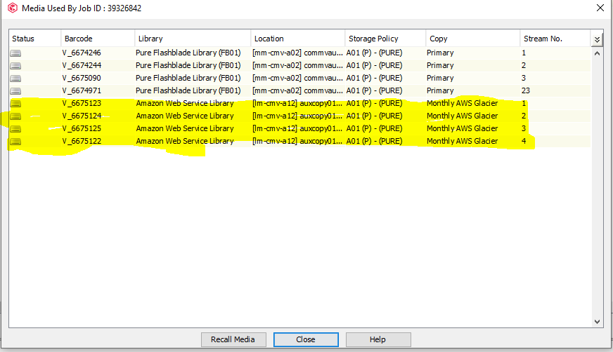

1. Double click the job and right click the job number and copy



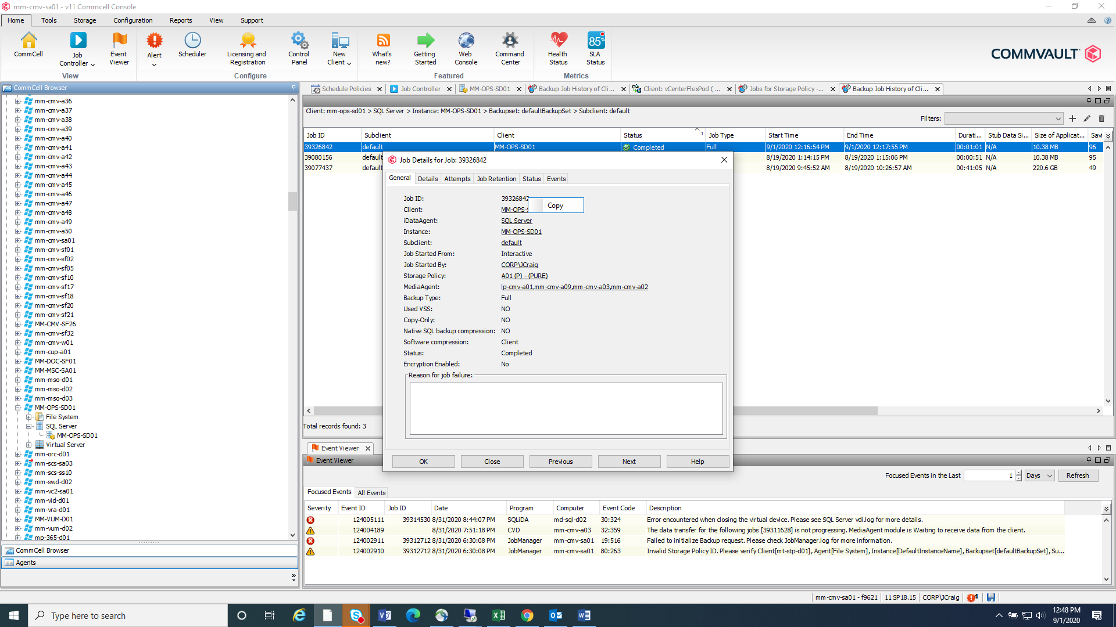

1. Go to Workflows

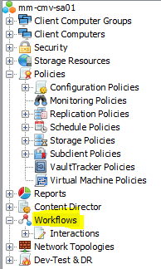

1. Choose **Cloud Storage Archive Recall**



1. Right Click > ***All Tasks*** and choose ***Execute***

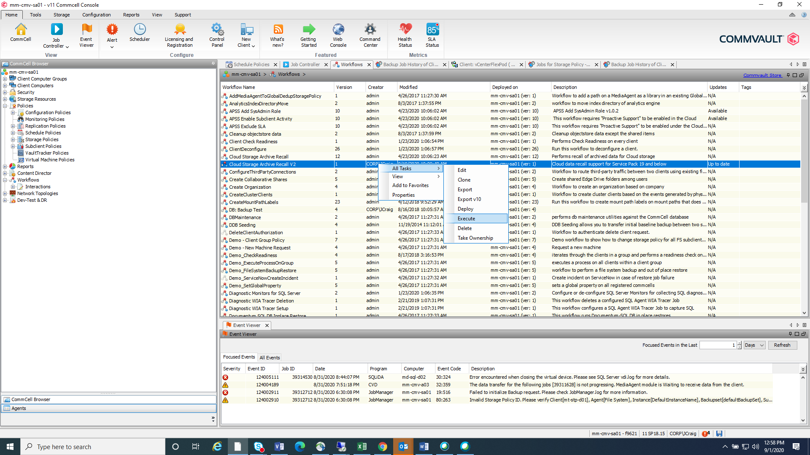

1. Once the dialog option appears, you will have to determine what type of restore you are performing.
   1. SQL – Paste the ***Job ID*** in the box, uncheck the ***Azure Settings*** and click ***OK***. Be aware, it may take **3-5 hours for the data to move**. It has to recall data from AWS Glacier to Standard IA. Once the data has been moved to AWS Standard-IA **(Workflow will complete)**, you may restore the database as normal. This will kick off another workflow automatically to transfer the data from AWS Standard-IA to your targeted SQL server. This data will remain in AWS Standard IA up to 7 days, and then it will return to Glacier.

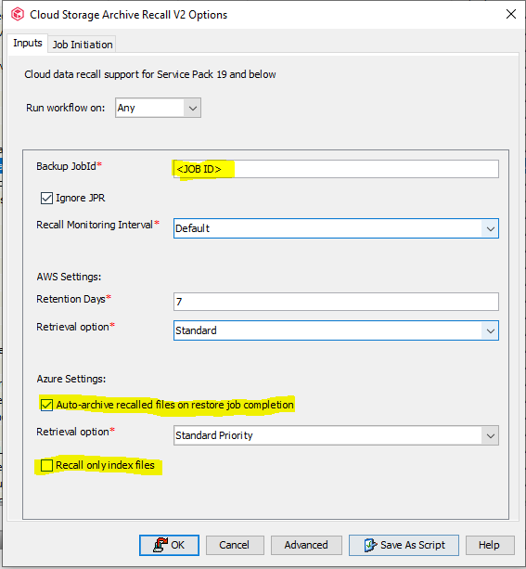

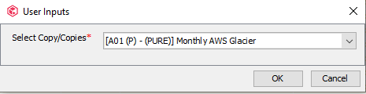

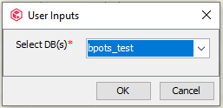

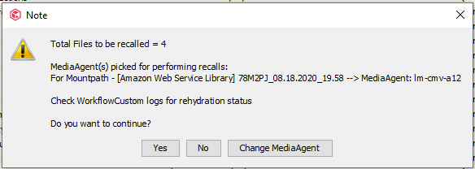

* 1. File Based/VMs – Paste the ***Job ID*** in the box, uncheck the ***Azure Settings*** and click ***OK***. You will need to restore the index first if you want to locate the file you are wanting. Check ***recall only index files***. This will recall the index from AWS Standard-IA and place them on the media agent. Once the index is recalled and you can find the file to restore, you can restore the job as normal. Be aware, it may take **3-5 hours for the data to move**. It has to recall data from AWS Glacier to Standard IA. Once the data has been moved to AWS Standard-IA **(Workflow will complete).** This data will remain in AWS Standard-IA up to 7 days, and then it will return to Glacier.

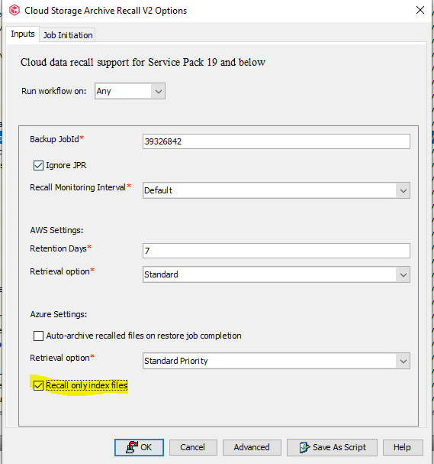

Change the media to lm-cmv-a01 to download the index to the disk….